
TEMASEK JUNIOR COLLEGE
Preliminary Examinations
Higher 2

CANDIDATE
NAME
CIVICS  GROUP |  |  | /

CHEMISTRY 9746/02
Paper 2 Structured Questions 28 September 2009
1 hour 30 minutes

Candidates answer on the Question Paper.
Additional Materials: Data Booklet

READ THESE INSTRUCTIONS FIRST

Write your Civics Group and candidate name on all the work you hand in.
Write in dark blue or black pen.
You may use a soft pencil for any diagrams, graphs or rough working.
Do not use staples, paper clips, highlighters, glue or correction fluid.

Answer all questions.

You are reminded of the need for good English and clear presentation in your answers.
You may lose marks if you do not use appropriate units.
A Data Booklet is provided.
The number of marks is given in brackets [ ] at the end of each question or part question.

For Examiner’s Use
1
2
3
4
5
Total

This paper consists of 16 printed pages.
Answer all questions in the spaces provided.

1 | This question is about chlorine and its compounds. |  |  |  | For Examiner’s Use
 | (a) | A teacher instructed a student to react some chlorine gas with 250 cm³ of 0.100 mol dm⁻³ aqueous sodium hydroxide, and left the lab. After he returned, he realized that he had not specified the reaction temperature. The teacher found that the pH of the solution had become 12.0. After acidifying the solution and adding excess silver nitrate, 2.69 g of silver chloride was obtained. He then concluded that the student had heated the sodium hydroxide.  For this question, you may assume that all of the chloride ions are precipitated by the addition of silver ions. |  |  | For Examiner’s Use
 |  | (i) | Determine how the teacher arrived at his conclusion.  [
 |  | (ii) | If the student had not heated the aqueous sodium hydroxide and the same amount of chlorine gas was used, what would be the resulting mass of silver chloride obtained when excess silver nitrate is added after acidifying the solution?  [5]
 | (b) | The melting point of POCl₃ is 1.25 ºC whereas the melting point of PCl₅ is 166.8 ºC. |  |  | For Examiner’s Use
 |  | (i) | Name and draw diagrams to illustrate the shapes of POCl₃ and PCl₅. |  | For Examiner’s Use
 |  | (ii) | Explain, in terms of structure and bonding, why PCl₅ has a higher melting point. |  | For Examiner’s Use
 |  |  | [4]
 | (c) | Phosphorous pentachloride is commonly used in organic reactions such as the following:  CH₃OH(l) + PCl₅(s) CH₃Cl(g) + POCl₃(l) + HCl(g) |  |  | For Examiner’s Use
 |  | (i) | With reference to the Data Booklet and the following bond enthalpies, calculate the enthalpy change of the above reaction.
  Bond | Bond Energy / kJ mol⁻¹
  P=O | 460
  P-Cl | 331
 |  | (ii) | Deduce whether the entropy change is positive or negative and hence explain why the above reaction occurs at room temperature.
 |  | (iii) | Given that the actual standard enthalpy change of reaction is −104.3 kJ mol⁻¹, suggest two reasons for the discrepancy.  [7]  [ |  | For Examiner’s Use
 | (d) | A student mixed up three test tubes containing chlorobenzene, trichloromethane and ethanoyl chloride separately.
 |  | (i) | Describe a chemical test to first identify ethanoyl chloride from among the three test tubes.  ●
 |  | (ii) | Describe a second chemical test to then identify trichloromethane from among the remaining two test tubes.  [4]  [Total: 20 marks] |  | For Examiner’s Use

2 | The use of the Data Booklet is required for this question. |  |  | For Examiner’s Use
 | (a)  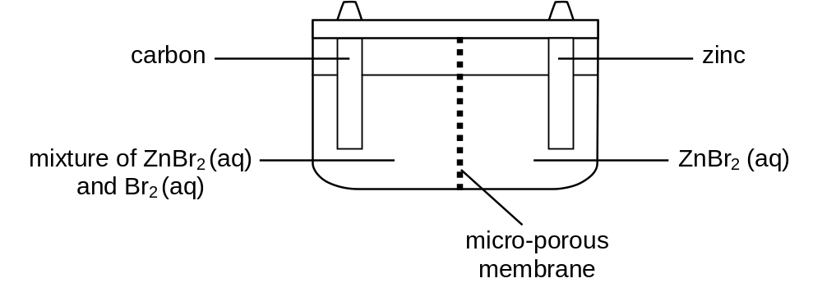 | Bromine is the only liquid non-metallic element at room temperature. It reacts vigorously with metals, especially in the presence of water, as well as most organic compounds, especially upon illumination.  Bromine is also used in the zinc-bromine flow battery which is a rechargeable battery. The two electrode chambers are separated by a micro-porous membrane which prevents bromine from reaching the zinc electrode where it would react with zinc, causing the battery to self-discharge. During the charging of the battery, bromide is converted to bromine. |  | For Examiner’s Use
 |  | (i) | In the table below, indicate the polarity (+/−) of the electrodes and write the half-equations for the electrode processes that occur when the battery discharges.
  Electrode | Polarity | Half-equation
  Zinc
  Carbon
 |  | (ii) | 4.2 g of bromine is formed in the cell when a current of 2.0 A is passed through it during charging. Determine the length of time required to form 4.2 g of bromine.  [ | For Examiner’s Use
 |  | (iii) | In a research laboratory, a research worker first charged a zinc-bromine battery fully before adding 10 cm³ of 0.2 mol dm⁻³ sodium bromide solution to each of the two electrode chambers.  What is the effect on the electrical output of the battery when it is discharged?  [8]
 | (b) | Ethanol fuel cells are more practical than hydrogen fuel cells since ethanol is easier to store and transport than hydrogen. Ethanol is oxidised into carbon dioxide and water when the fuel cell is operated.  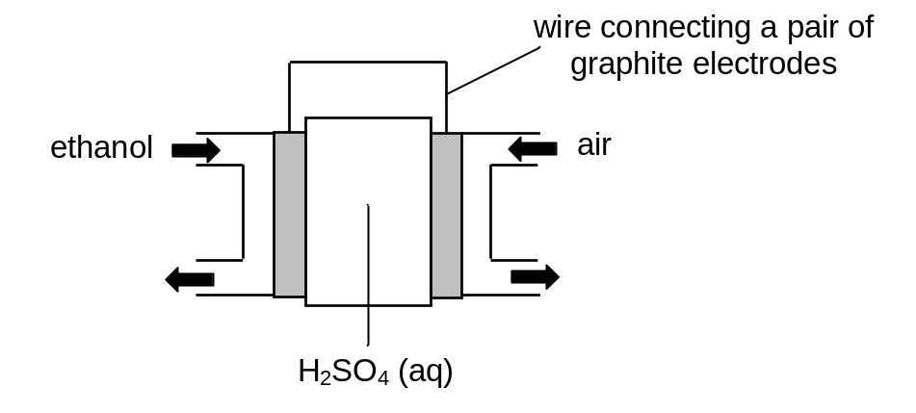 |  | For Examiner’s Use
 |  | (i) | Write the half-equations taking place at each of the electrode:  Anode: ____________________________________________  Cathode: ____________________________________________  [2]
 |  | (ii) | Use appropriate data from the Data Booklet to explain why an acidic electrolyte is often preferred to an alkaline or neutral electrolyte.  [4]
 | (c) | Ethanol can be oxidised to form ethanoic acid, which is used to prepare pyruvic acid, CH₃COCO₂H in a 3-step synthesis.  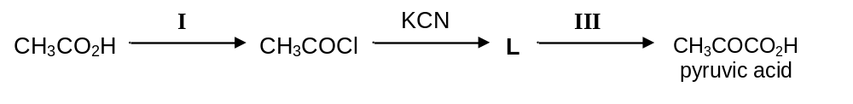 |  | For Examiner’s Use
 |  | (i) | State the reagents and conditions for stages I and III.  Stage I: ____________________________________________  Stage III: ____________________________________________
 |  | (ii) | Identify the intermediate compound, L.  [3]  [Total: 15 marks]
3 | The first six ionisation energies of three successive elements in a Periodic Table are given below: |  |  | For Examiner’s Use
   | Ionisation energy in kJ mol⁻¹
  Element | 1st | 2nd | 3rd | 4th | 5th | 6th
  A | 786 | 1580 | 3230 | 4360 | 16100 | 19800
  B | 1060 | 1900 | 2920 | 4960 | 6270 | 21300
  C | 1000 | 2260 | 3390 | 4540 | 7000 | 8500
 | (a) | State and explain the group of the Periodic Table which element B belongs to.  [2] |  | For Examiner’s Use
 | (b) | Explain why the first ionisation energy of B is higher than the first ionisation energies of A and C.  [3]  [Total: 5 marks] |  | For Examiner’s Use
4 | Tertiary structure refers to the complete three-dimensional structure of the polypeptide units of a given protein. Included in this description is the spatial relationship of different secondary structures to one another within a polypeptide chain and how these secondary structures themselves fold into the three-dimensional form of the protein. Secondary structures of proteins often constitute distinct domains. The secondary protein structure is the specific geometric shape caused by intramolecular and intermolecular bonding of amide groups.
 | (a) | Draw a diagram showing three strands of an anti-parallel β-pleated sheet structure of a protein. On the diagram, indicate the type of intermolecular force that holds the protein chains together.  [2]
 | (b) | When a protein is denatured, the tertiary structure is disrupted. Explain in chemical terms how R group interactions are broken in each of the following situations. In your answer, identify the type of R group interaction which is broken for each example.  [R group = alkyl group] |  | For Examiner’s Use
 |  | (i) | In the presence of metal ions, e.g. Ag⁺.
 |  | (ii) | At pH 2.  [4]  [Total: 6 marks]
5 | (a) | Cocaine is commonly used in drug abuse but medicinally, it is valued as a local anaesthetic. Synthetic drugs developed from cocaine have been introduced to provide safer, less toxic local anaesthetic action. One of them is lignocaine which is currently the most widely used anaesthetic, having rapid action, effective absorption and good stability.  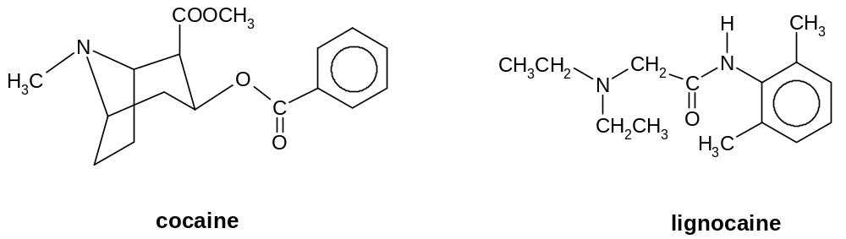 |  | For Examiner’s Use
 |  | (i) | Identify the functional groups that are present in lignocaine.
 |  | (ii) | Label all the chiral centres in the two molecules above with asterisk (*).
 |  | (iii) | When lignocaine is boiled with aqueous sodium hydroxide, two compounds, X and Y, are formed. X is soluble in aqueous sodium hydroxide while Y is immiscible with aqueous sodium hydroxide.  Identify the structural formula of X and Y.  X  Y
 |  | (iv) | Explain why X is soluble in aqueous sodium hydroxide while Y is immiscible with aqueous sodium hydroxide.  [8] | For Examiner’s Use

 | (b)  T + U | Using simple molecules like 2,6-dimethylphenylamine, ammonia and chloroethane, lignocaine can be synthesised as shown below.  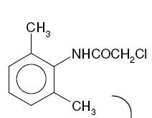  r.t.p.  S  T  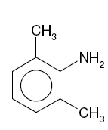  +  U  heat in  sealed tube  NH₃ + CH₃CH₂Cl  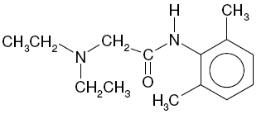  lignocaine
 |  | (i) | Draw the displayed structural formulae of the starting material, S and the intermediate, U in the boxes above. | For Examiner’s Use
 |  | (ii) | What problem do you foresee in the synthesis of intermediate U? Explain briefly.
 |  | (iii) | T can be used as a starting material to synthesise 4-bromo-2,6-dimethylphenylamine via the following route:  V  NaOH(aq)  reflux  T  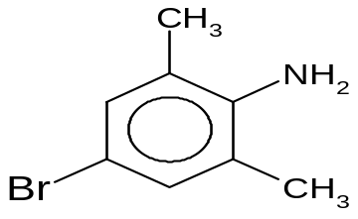  4-bromo-2,6-dimethylphenylamine
 |  |  | In the box above, draw the structure of V.
 |  | (iv) | State the reagent and condition to convert V to 4-bromo-2,6-dimethylphenylamine.  [6]  [Total: 14 marks]
 |  |  |  | For Examiner’s Use

